
PERTH COLLEGE

YR 12 3CD SPECIALIST MATHEMATICS
SEMESTER ONE 2010
TEST 2

Name: Time : 50 mins Total marks : /45 = %

- Answer all questions neatly in the spaces provided.
- Show all working where appropriate.
- Calculator & Formula Sheet allowed

1) (3, 3 marks)
If x = 3t² + 4t and y = 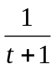 find
a)  in terms of t ,

b) 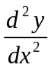 in terms of t

- (2, 3, 3, 4, 6 marks)

Determine the following integrals. Show appropriate working for full marks.

a) 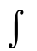3x² + sinx dx

b) 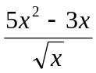 dx

- 6x² 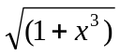 dx

- cos² x sin³ x dx

e) 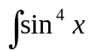 dx

- (5, 5 marks)

Perform the following integrations using the given substitutions. Show all working.
a) 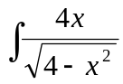 dx let x = 2 sin

b) 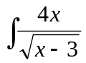dx let u = x – 3

- (4 marks)

The equation of the gradient to a curve is given by
g′(x) = 4 + 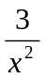+ 2cos
If the point (1,2) lies on the curve, find the equation of g(x)

5) (7 marks )

In a cricket match, a ball is hit from B at a constant speed of 30 ms⁻¹ towards a
fieldsperson at F, located 50 metres from B along the bearing 290º.
An umpire is standing at U, 20 metres from B along bearing 350º .
Determine how fast the distance between the ball and the umpire is changing when
the ball has travelled half-way towards the fieldsperson. Assume that the fieldsperson
and the umpire have not moved from their respective positions.
